Project Design Phase-II
Technology Stack (Architecture & Stack)

Date | 11 February 2026
Team ID | LTVIP2026TMIDS88533
Project Name | Explore with AI: Custom Itineraries for Your Next Journey
Maximum Marks | 4 Marks

Technical Architecture:

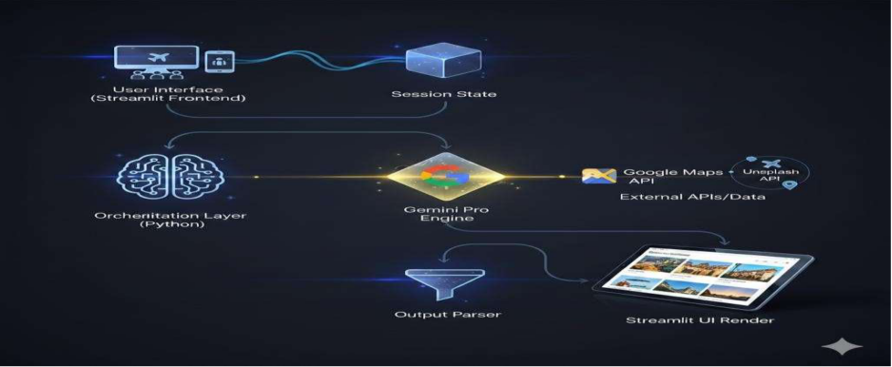

Table-1: Components & Technologies:

1 | User Interface | Interactive web interface where users enter destination, budget, duration, and preferences | Streamlit

3 | Generative AI Engine | Generates personalized travel itineraries based on user preferences | PaLM API (Google Generative AI)
4 | Prompt Engineering Layer | Designs structured prompts to ensure accurate and relevant itinerary generation | Custom Prompt Templates (Python)
5 | Response Processing | Formats AI-generated itinerary into readable sections (Day-wise plan, budget tips, etc.) | Python
6 | Deployment Environment | Hosting and deployment of Streamlit application | Streamlit Cloud / Local Deployment
7 | Future Enhancement | Save itineraries, recommendation learning, user preference memory | Database Integration (Future Scope)

